1. 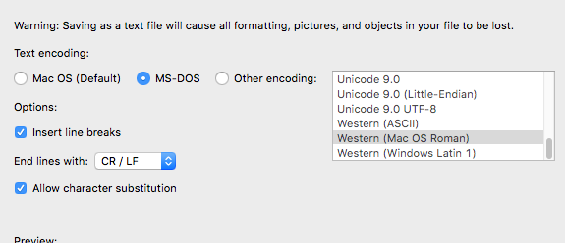Create two separate text files. The first text should be the sequences you are looking for matches for. The second text should be the entire database of sequences you have that you are using to compare. Make sure that the text file has line breaks between each sequence. If you are unsure, you can always copy and paste the sequences into a Word file and then save it as a .txt file with the following features:
2. Macintosh HD:Users:legalllab:Desktop:Screen Shot 2018-08-02 at 9.58.51 AM.pngOpen **fuzzy_match_peptides.py** and go onto line 32 to change the path and name of the first and second text file to the corresponding text files you created in step 1.
3. Go onto terminal and move into the PycharmProjects directory. Once you are inside the directory, type in the following command to run the program: python PDB/fuzzy_match_peptides.py > PDBResults/name_fuzzymatchresults_date.xls
4. Once the program is finished running, indicated by the $ prompt on the terminal popping up again, open the results from the.xls file.
5. Highlight the entire first column and do a character replacement by doing a “cmd-F”. Replace the following characters: “(‘” , “),” , “\r\n,”

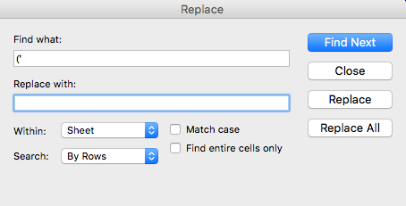

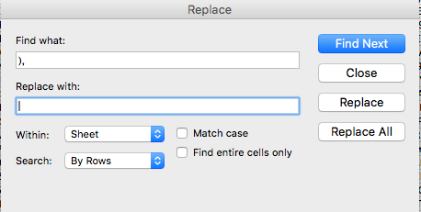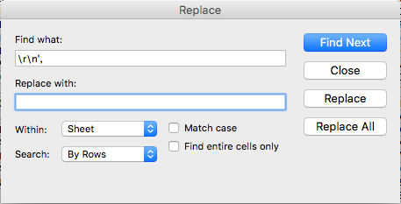

1. Reformat column A with “Text to Columns” with the following requirements:

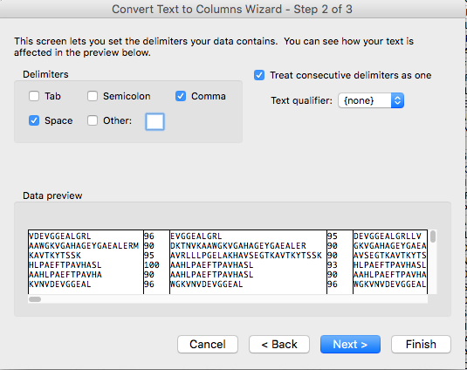

1. Add a new column before the first one. Copy and paste the sequences from your other .xls file that you had used to match (the sequences from the first text file) into column A.

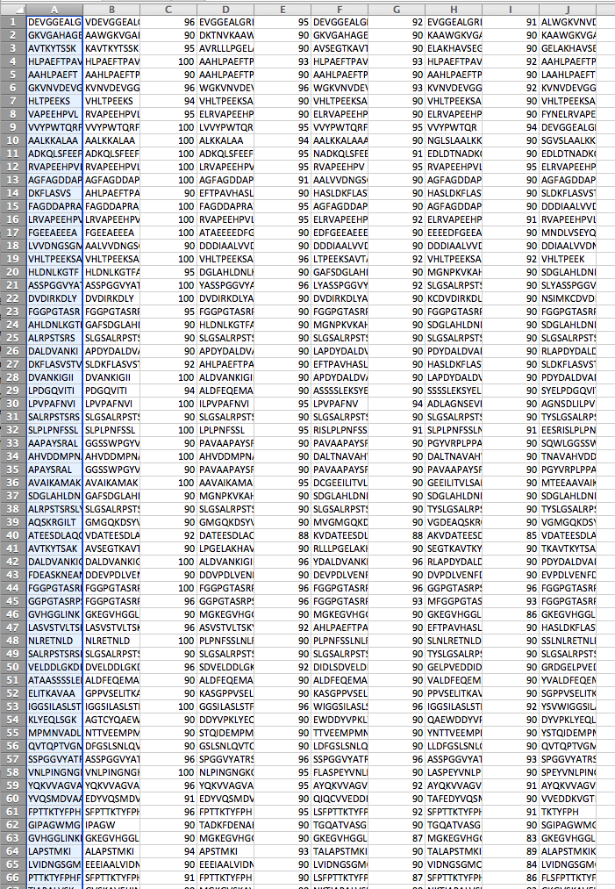

1. This is what your file should look like now!

